How to use Zaprite’s Auto-pay feature via API

## Step 1: Enable Auto-pay on a custom Checkout

First, create a custom Checkout for your API calls here:

<https://app.zaprite.com/org/default/checkouts/new>

Activate any of the Payment Methods that are compatible with Auto-pay. In your Live account, this will be **Square** or **Stripe** for example. In our Sandbox environment, you can use the **Test Payment (Card)** payment method.

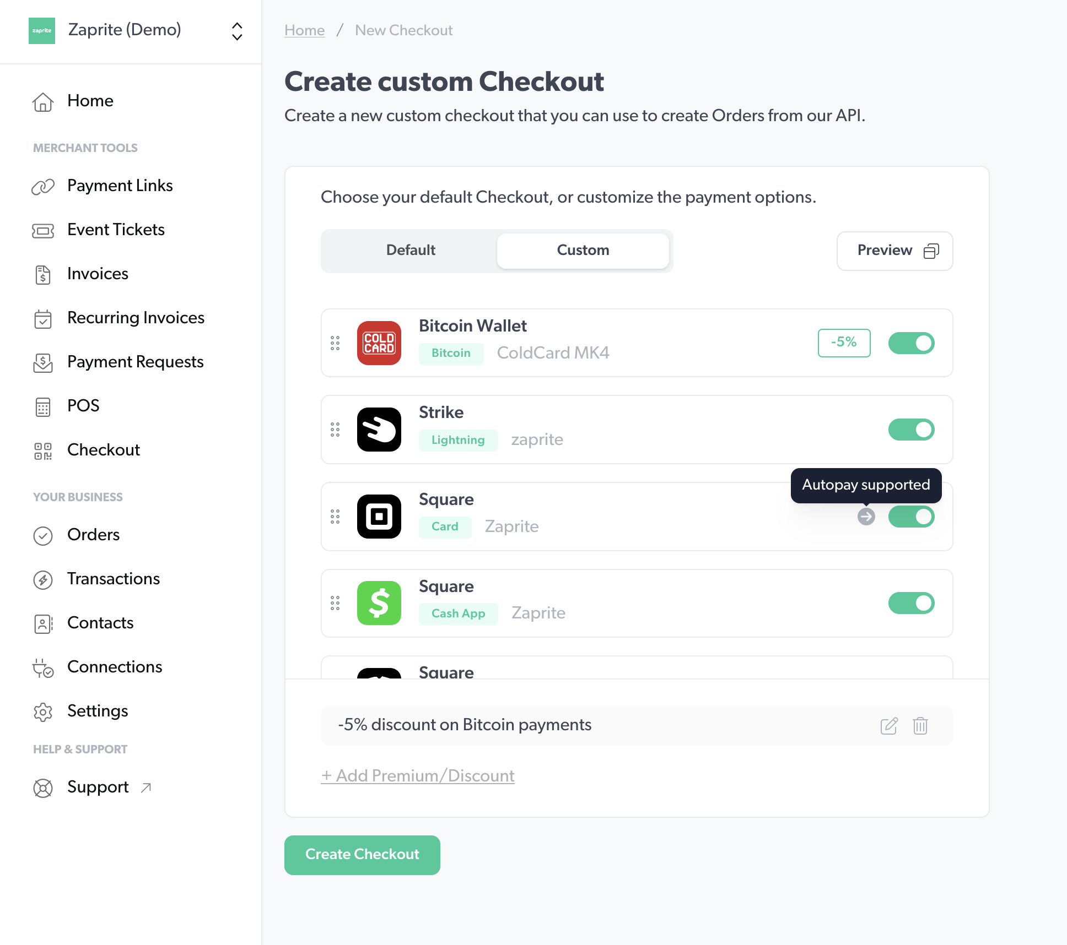

When you Save your Custom Checkout above, you will be shown a customCheckoutId. Make sure you copy and save this for the next step. You won’t be able to retrieve it again.

## Step 2: Create Order

The next step is to create an *Order* using Zaprite’s API via the /v1/order endpoint, passing through the customCheckoutId from above. You can also add a contactId to the *Order* here.

| If your *Contact* already has a saved *Payment Profile*, you can skip to **Step 5**. If not, Steps 3 and 4 allow your Customer to save their card on file. |
| --- |

***Note****: We have added new API endpoints where you can query your Contacts and any associated Payment Profiles.*

## Step 3: Request Payment

Next, send the checkoutUrl which is returned in the API response to your *Contact* to request the first payment, and offer the Customer the opportunity to save their card on file.

## Step 4: Customer saves their card on file

When your *Contact* makes their first payment, they can check the box on the *Checkout* that allows them to save their card on file for future payments. This creates a paymentProfile attached to the contact in Zaprite.

## Step 5: Pay Order

Now that you have a *Contact* with a saved paymentProfile, you can use this *Payment Profile* ID to auto-pay future Zaprite Orders.

Use the /v1/order/charge endpoint to attempt to auto-pay the Order. This endpoint currently takes three required values:

* orderId // string
* paymentProfileId // string
* sendReceiptToCustomer // boolean

If the attempt to Auto-pay the order is successful, your *Contact* will receive an email receipt, if indicated.

If the attempt to Auto-pay the invoice fails (card declined, card disabled, etc.) you can then revert to **Step 3** above to send the checkoutUrl from the original *Order* to your *Contact* for payment.

**Next**: [Testing](?tab=t.buvdokbajxv3)